**Product Performance Analysis**

10/09/2023

Mubeen Arshad

**Data Selected:**

Product sales and retail data

**Data transformation:**

1. **Product table:**

Removed the blank rows and promoted the first row as a header row.

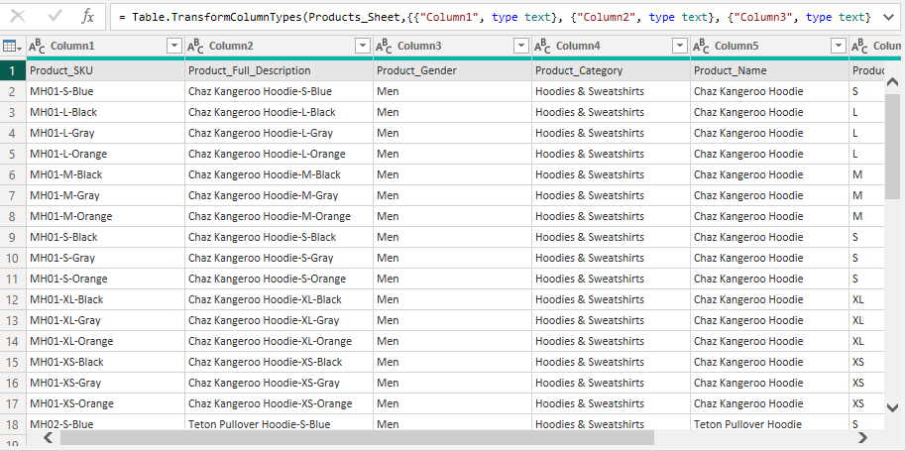

1. **Returns table:**

Changed the data types of Order_ID, Return_Time, and Return_Date into whole number, time, and date respectively. Deleted three columns of Return_Year, Return_Month, and Return_Day because the Return_Date column is already given. Merge the columns of Hour, Minute, and Seconds by creating a custom column as Return_Time. This makes it easier to work with and understand the time data.

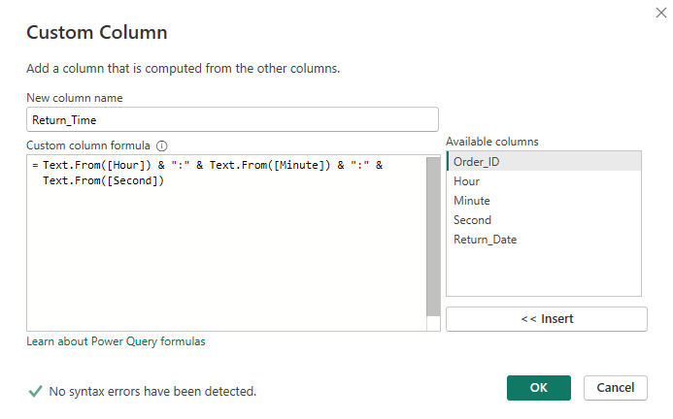

1. **Orders table:**

Deleted the Order_YearMonth column because Order_Date column is already given, and it’s not needed. Changed the data types into an appropriate format for accurate analysis.

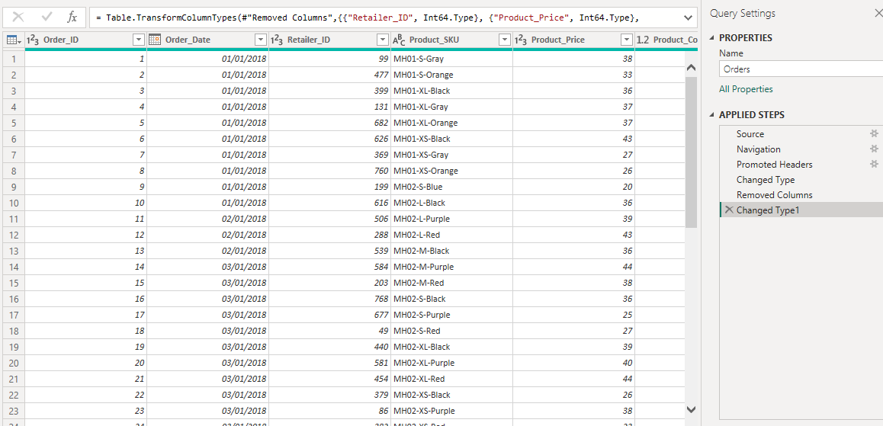

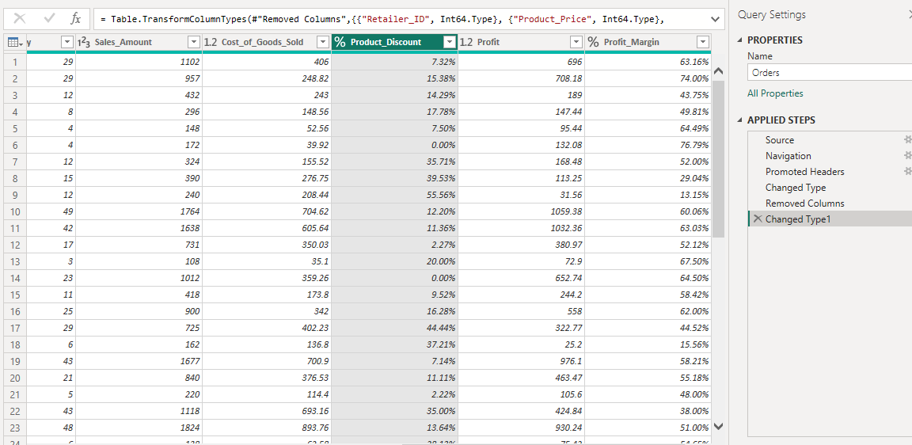

1. **Retailers table:**

Changed the data types appropriately for further analysis.

**Created Measure:**

A measure is created for total returns by applying the following DAX.



**Relationship:**

* **Product and Orders Tables:**

This is a one-to-many relationship, as each product can appear in many orders, but each order can contain only one product.

* **Retailers and Orders Tables:**

This is also a one-to-many relationship, as each retailer can have multiple orders, but each order is associated with only one retailer.

* **Orders and Returns Tables:**

This is a many-to-one relationship, as many returns can be linked to the same order, but each return is associated with only one order.

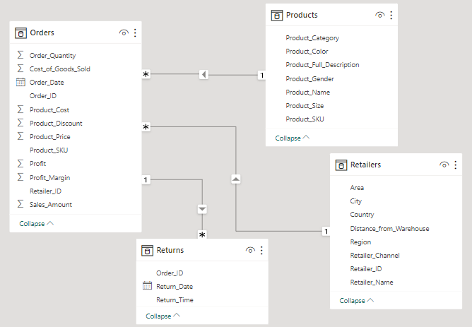

**Stakeholders:**

Product managers because they closely monitor the analysis to make informed decisions about product development, and marketing.

Sales and marketing teams will use the report to understand the product performance more deeply and analyze which product categories need additional marketing efforts. They can also use the data for campaigns and promotions.

**Analysis and Insights:**

I performed an analysis on product performance. Here are the analysis and insights on the product performance by considering various dimensions such as category, attributes, retailer influence, and seasonal trends.

1. **Sales amount and profit by product category:**

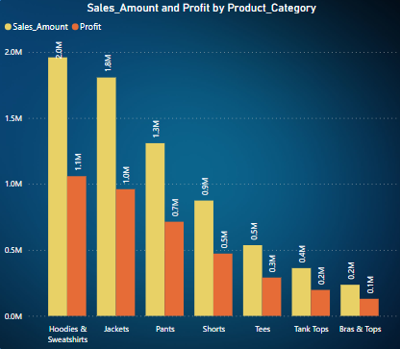

**Insights:**

The analysis reveals that the hoodies & sweatshirts are the top performer in terms of both sales and profit and generates the highest profit. Jackets also perform well and second highest contributor in revenue and profit followed by the pants. Tank tops and bras & tops are lowest sales and profit figures, suggesting it may require more attention to improve its performance.

1. **Sales amount by product size and product gender:**

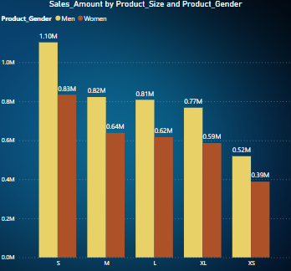

**Insights:**

The analysis reveals that the product for men are highest sales amounts as compared to the product designed for women across all size categories. The product size also appears to influence sales. The small size category has highest sales amount followed by medium, large, and extra-large.

1. **Profit and sales amount by retailer channel according to the product categories:**

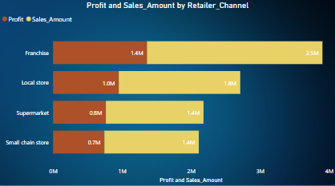

**Insights:**

Franchise retailers generate the highest sales and profit figures specifically for the "Hoodies and Sweatshirts" category followed by local stores and supermarkets. Local stores and small chain stores are contributing well to sales and profitability for the categories of hoodies and sweatshirts, tank tops, and bras & tops. Sales of "Tees" are relatively evenly distributed among different retailer channels, with no single channel significantly dominating the category.

1. **Sales amount and profit by month for product categories:**

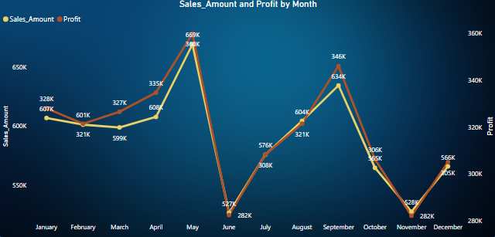

**Insights:**

Hoodies and sweatshirts achieved the highest sales and profits in January. Jackets outperformed other products in February. Pants exhibited strong sales and profitability, with March being the starting point and April being the peak month. Shorts consistently performed well from July to October. Tank tops delivered impressive results, particularly in October. Finally, bras and tops recorded their highest sales figures in January.

1. **Total returns by product category:**

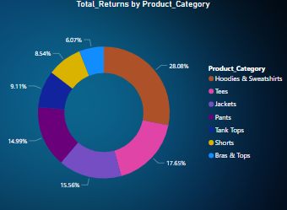

**Insights:**

The hoodies & sweatshirts category has the highest return rate among all product categories, indicating a significant number of returns relative to sales. Categories such as shorts, tank and tops, and bras & tops have relatively lower return rates, indicating that customers are generally satisfied with these products.

**Recommendations:**

1. Given that "Hoodies and Sweatshirts" are the top performers, a company should consider expanding and promoting products within this category and explore opportunities to introduce new styles or variations. While on the other side "Jackets" are performing well so ensure that the product range remains updated and seasonally relevant to maintain strong sales and profitability. The “Bras and Tops” category is giving the lower sales and profit so conduct a thorough review to understand the factors contributing to this performance. Apply some potential improvements or adjustments in product offerings.
2. Capitalize on the preference for gender male products by optimizing marketing strategy and inventory management for this segment. For gender females, explore targeted marketing strategies or product enhancements for increasing sales and profitability. As "Small" sizes tend to perform well, so ensure adequate stock levels and variety in this size category. A company should consider product development efforts focused on creating or promoting gender-specific designs or features that align with customer preferences.
3. Needs to strengthen partnerships with franchise retailers and explore opportunities for collaboration or exclusive product lines. A company should also look at segmenting customers based on their preferred retail channels and product categories.
4. As “Hoodies and Sweatshirts” are generating high sales and profit but need to reevaluate the specific reasons for the high return rate in the "Hoodies and Sweatshirts" category as well. Are there quality issues, sizing problems, or other factors driving returns? Addressing these issues can help reduce returns. Also, establish a feedback loop with customers to gather insights into why they are returning products. Use this feedback to make necessary adjustments to product design, quality, or sizing.